BABY CLASS NUMBERS LESSON NOTES TERM I 2026
LEARNING AREA4 (DEVELOPING AND USING MATHEMATICAL CONCEPTS IN MY DAY-TO-DAY EXPERIENCES).
TERM ONE NOTES
WEEK1
ORIENTATION OF THE BABIES IN ACCEPTABLE WAYS

WEEK2
Recognizing zero 0
Shading Pasting and Tracing
Recognizing number, I


Pasting Shading Tracing Copying
Suggested developmental activities.
- Singing number songs(e.g.)
“One yellow duck swimming in the water,two yellow ducks swimming in the water……
- Shading,
- Pasting,
- Tracing,
- Sorting
- Writing in the air, on table, on slates and in books (number formation a standing stick)
- Tearing,
- Countingorally1-5
- Fixing jigsaws
- Matching
- Playing domino games,


WEEK3
Recognizingnumber2
2

Shading Pasting Tracing Copying
Suggested developmental activities.
- Counting orally 1-5
- Shading number 2
- Pasting number 2
- Recognizing number 2
- Tracing number 2
- Sorting number 2
- Copying number 2(number formation a curve and a sleeping stick)
- Grouping objects in twos i.e counting eyes, legs, hands…..
- Shading, pasting, tearing
- Matching
WEEK4
Recognizing number 3

3

Shading Pasting Tracing Copying
Suggested developmental activities
- Counting orally 1-5
- Recognizing numbers 1-3
- Shading number 3
- Tracing number 3
- Copying number 3(later formation a curve and acurve)
- Drawing for the number 3
- Pasting
- Sorting number 3i.e.circle the given number)
- Matching

WEEK5
Recognizingnumber4

4
Shading Pasting Tracing Copying
Suggested developmental activities.
- Recognizing number 1-4
- Reciting number 4
- Shading
- Pasting number 4
- Tracing number 4
- Matching
- Counting
- Writing (number formation slanting line sleeping stick and short standing stick

WEEK6
Recognizingnumbers1–5
1 2 3 4 5
Matching the same number
1 2 3 4 5

1 3 2 5 4
Suggested developmental activities
- Counting orally numbers 1–5
- Recognizing numbers 1-4
- Playing domino games
- Matching
- Writing on the chalkboard or slates
- Drawing
- shading

WEEK7
- Recognizing number 5

Pasting Shading Tracing Copying
Suggested developmental activities
  - Reciting numbers 1-5
  - Counting objects
  - Pasting
  - Coloring
  - Tracing
  - Copying and Writing(number formation sleeping stick, slanting stick and a curve)
  - Drawing for the number
  - Tearing
  - Playing number games(e.g.)
WEEK8
- Recognizes1-5,
- Circle the same letter


Suggested developmental activities
- Reciting numbers 1-5
- Identifying numbers 1-5
- Circle the same numbers
- Writing numbers correctly
- Counting objects
- Count number and write
- Count and match
- Circling the correct number
- Draw for the number
- Shade for the number
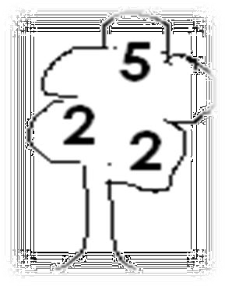
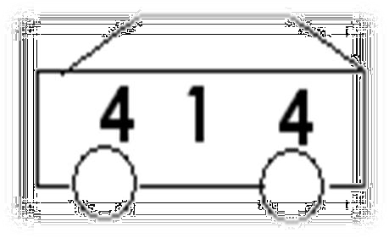

Activity
Count and match1

2
3 
5

4

Count number and write


Circle the given num | ber
1 | 6 | 1 | 7
2 | 9 | 2 | 10
3 | 0 | 8 | 3
4 | 5 | 4 | 9

WEEK9
Recognizing different shapes.
- Introducing a lesson on with a rhyme about shapes e.g.

“A ma music man
I come from far away I can draw square

Square x2”
- Get objects with different shapes to show learners
- Youcanalsouserealobjectslikewindowsanddoorstoshowthemdifferentshapes.

Suggested developmental activities
- Recognizing different shapes
- Tracing different shapes
- Shading, pasting and shading different shapes like circle, square, triangles etc.
- Naming different types of shapes or all

Activity
Matching the same shapes

Colour the shapes

Trace the shapes
WEEK10
Suggested developmental activities
- Naming different types of shapes orally
- Complete the shapes
- Cuttingandfoldingshapesusingconcretematerialse.g.buildingblockstomakedifferent shapes.
- Sorting
- Fitting jig saws
- Using concrete materials e.g.building blocks to make different shapes.
- Playing domino games
- Describing ,sorting and comparing three-dimensional objects according to
- Size
- Objects that roll
- Objects that slide
- Sorting objects according to size shapes and color.

Activity
Circle the different

Colour the same
Complete the shapes



